

Submitted by:
Name: Istiak Alam
ID: 05
Batch: 20
Lab report: 07
Date: 19.11.22
Course: CSE LAB
Course Code: 1202
Lab task Topic: Structured Programming Problems Solve {Switch case}

Submitted to:
Nafisa Tabassum

LECTURER, NDUB

Problem No. 01
Name of the problem:
Write a C program using a switch case to check whether the number entered by the user is odd or even.
Introduction
Implementing program in C is very interesting. To implement the problem given above we should remember the procedure to display outcome. That is, we should consider about the required inputs, the particular process that will be applied upon the input data and the output whether it is desired or not. The given problem gives me an opportunity to have an exercise on the procedure.

Program:
//check whether the number entered by the user is odd or even using switch case
#include <stdio.h>
int main()
{
int number;
printf("Enter a positive integer number: ");
scanf("%d",&number);
switch(number%2) //this will return either 0 or 1
{
case 0:
printf("%d is an EVEN number.\n",number);
break;
case 1:
printf("%d is an ODD number.\n",number);
break;
}
return 0;
}
Output :
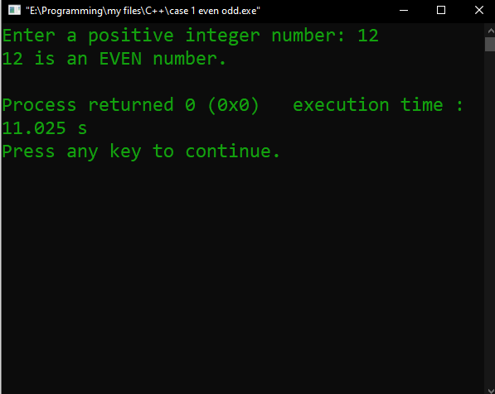

Problem No. 02
Name of the problem:
Write a C program to checks whether a character entered by the user is a vowel or not by using the switch case statement.
Introduction
Implementing program in C is very interesting. To implement the problem given above we should remember the procedure to display outcome. That is, we should consider about the required inputs, the particular process that will be applied upon the input data and the output whether it is desired or not. The given problem gives me an opportunity to have an exercise on the procedure.

Program:
//checks whether a character entered by the user is a vowel or not by using the switch case statement
#include <stdio.h>
int main()
{
char ch;
printf("Enter any alphabet: ");
scanf("%c", &ch);
switch(ch)
{
case 'a':
printf("Entered Alphabet is Vowel");
break;
case 'e':
printf("Entered Alphabet is Vowel");
break;
case 'i':
printf("Entered Alphabet is Vowel");
break;
case 'o':
printf("Entered Alphabet is Vowel");
break;
case 'u':
printf("Entered Alphabet is Vowel");
break;
case 'A':
printf("Entered Alphabet is Vowel");
break;
case 'E':
printf("Entered Alphabet is Vowel");
break;
case 'I':
printf("Entered Alphabet is Vowel");
break;
case 'O':
printf("Entered Alphabet is Vowel");
break;
case 'U':
printf("Entered Alphabet is Vowel");
break;
default:
printf("Consonant");
}
return 0;
}

Output :
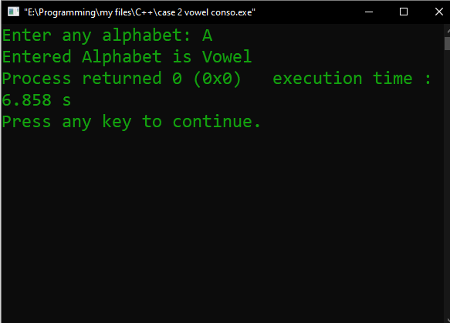

Problem No. 03
Name of the problem:
Write a menu-driven C program to find the area of the circle, area of the triangle and area of the rectangle according to the user’s input choice
Introduction
Implementing program in C is very interesting. To implement the problem given above we should remember the procedure to display outcome. That is, we should consider about the required inputs, the particular process that will be applied upon the input data and the output whether it is desired or not. The given problem gives me an opportunity to have an exercise on the procedure.
Program:
//finding area of circle, rectangle, triangle
#include <stdio.h>
int main()
{
printf("\tMenu of shapes\n");
printf("Select your shapes:\n");
printf("1.Area of circle.\n2.Area of reactangle.\n3.Area of tringle.\n\n");
printf("Enter your choice:");
int m,breadth,length,h,e;
float radius,area;
scanf("%d",&m);
switch(m)
{
case 1:
{
printf("\tArea of circle\n");
printf("Enter the radius:");
scanf("%f",&radius);
area = 3.142*radius*radius;
printf("Area of a circle = %f\n", area);
}
break;
case 2:
{
printf("\tArea of rectangle\n");
printf("Enter the breadth and length:");
scanf("%d %d", &breadth, &length);
area = breadth*length;
printf("Area of a Reactangle = %f\n", area);
}
break;
case 3:
{
printf("\tArea of triangle\n");
printf("Enter the height value of the triangle :");
scanf("%d", &h);

printf("Enter the edge value of the triangle :");
scanf("%d", &e);

area=0.5*(h*e);
printf("The area of the triangle is:%d", area);
}
break;

default:
printf("\tInvalid Menu");
break;}}

Problem No. 04
Name of the problem:
Write a menu-driven C program to convert a given year into, Months Days Hours Minutes Seconds. For simplicity don’t include leap year, use 1 Year = 365 days 1 Month = 30 days
Introduction
Implementing program in C is very interesting. To implement the problem given above we should remember the procedure to display outcome. That is, we should consider about the required inputs, the particular process that will be applied upon the input data and the output whether it is desired or not. The given problem gives me an opportunity to have an exercise on the procedure.
Program:
//convert a given year into month,day
#include<stdio.h>
int main()
{
int m,years,months,days,hours,minutes,seconds;
printf("Select your choice to convert a year into:\n");
printf("1.Month\n2.Days\n3.Hours\n4.Minutes\n5.Seconds\n");
printf("Enter your choice:");
scanf("%d",&m);
printf("\nEnter the number of years:");
scanf("%d",&years);
switch(m)
{
case 1:
{
months = 12 * years;
printf("\n%d years = %d Months",years,months);
}
break;
case 2:
{
days = 365 * years;
printf("\n%d years = %d Days",years,days);
}
break;
case 3:
{
hours = 24 * 365 * years;
printf("\n%d years = %d Hours",years,hours);
}
break;
case 4:
{
minutes = 60 * 24 * 365 * years;
printf("\n%d years = %d minutes",years,minutes);
}
break;
case 5:
{
seconds = 60 * 60 * 24 * 365 * years;
printf("\n%d years = %d seconds",years,seconds);
}
default:
printf("Invalid Menu");
}
return 0;
}
Bonus Problem
Name of the problem:
A computer showroom has announced the following seasonal discounts on purchase of items: Purchase Amount Discount Pen Drive RAM 0-100 --- 5% 101-200 5% 7.5% 201-300 7.5% 10.0% Above300 10.0% 15.0% Write a program using switch and if statements to compute the net amount to be paid by a customer
Introduction
Implementing program in C is very interesting. To implement the problem given above we should remember the procedure to display outcome. That is, we should consider about the required inputs, the particular process that will be applied upon the input data and the output whether it is desired or not. The given problem gives me an opportunity to have an exercise on the procedure.
Program:
//Shop For Pendrive & Ram
#include<stdio.h>
int main()
{
int amount,price,ch;
float net,discount,amountToBePaid;
printf("\tShop\n1.Pendrive purchase\n2.Ram purchase\n");
printf("Enter your choice");
scanf("%d",&ch);
printf("\n Enter purchased amount: ");
scanf("%d",&amount);
printf("Enter the price per item: ");
scanf("%d", &price);
net = amount * price;
switch(ch)
{
case 1:
if(amount<=100)
{
amountToBePaid = net;
printf("After applying the discount, you have to pay: %0.2f", amountToBePaid);
}
else if(amount>=101 && amount<=200)
{
discount = (net*5)/100;
amountToBePaid = net-discount;
printf("After applying the discount, you have to pay: %0.2f", amountToBePaid);
}
else if(amount>=201 && amount<=300)
{
discount = (net*7.5)/100;
amountToBePaid = net-discount;
printf("After applying the discount, you have to pay: %0.2f", amountToBePaid);
}
else if(amount>300)
{
discount = (net*10)/100;
amountToBePaid = net-discount;
printf("After applying the discount, you have to pay: %0.2f", amountToBePaid);
}
break;
case 2:
if(amount<=100)
{
discount = (net*5)/100;
amountToBePaid = net-discount;
printf("After applying the discount, you have to pay: %0.2f", amountToBePaid);
}
else if(amount>=101 && amount<=200)
{
discount = (net*7.5)/100;
amountToBePaid = net-discount;
printf("After applying the discount, you have to pay: %0.2f", amountToBePaid);
}
else if(amount>=201 && amount<=300)
{
discount = (net*10)/100;
amountToBePaid = net-discount;
printf("After applying the discount, you have to pay: %0.2f", amountToBePaid);
}
else if(amount>300)
{
discount = (net*15)/100;
amountToBePaid = net-discount;
printf("After applying the discount, you have to pay: %0.2f", amountToBePaid);
}
break;
}
getch();
}

THE END

